**Assignment #6: 25 points**

To answer the following questions, please use the **XL file labeled “Powerade Data for Students”.** This is the type of data you would likely come across if you are working in brand management. The survey data represent the number of bottles of Powerade (your product) used in the past 30 days, and the same information on Gatorade (competitor). For this assume that there are no other brands in the category.

Using **XL PIVOT tables**, please answer the following question **(and include sample size in all of your pivot tables** – and include the appropriate XL output in your homework). **You may need to create new variables to complete this part of the assignment.**

**Each of these questions should be answered using a single pivot table (i.e. don’t divide two numbers by hand to get the repeat rate), and the answer should be highlighted.**

**Sample size should be included (first) in all of your pivot tables**

**Remember to copy and paste the pivot table for each question, and highlight the answer.**

1. How many customers are in the category?

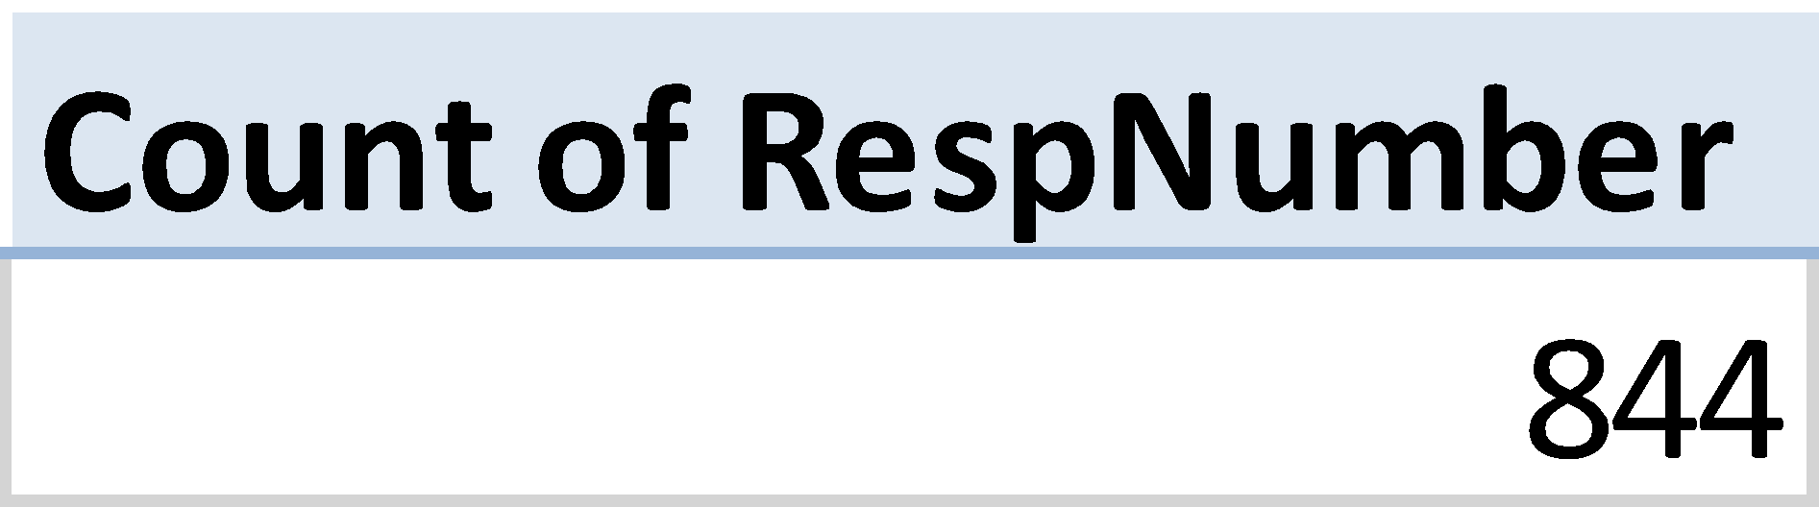

1. Create a new variable for Powerade triers (or buyers). Copy and paste the XL code used to create this variable

**=IF(C2="","",IF(C2>=1,1,0))**

1. How many Powerade buyers are there?

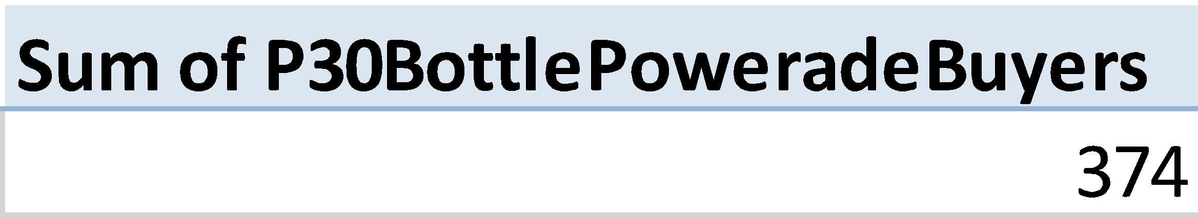

1. What percent of the sample is Powerade buyers

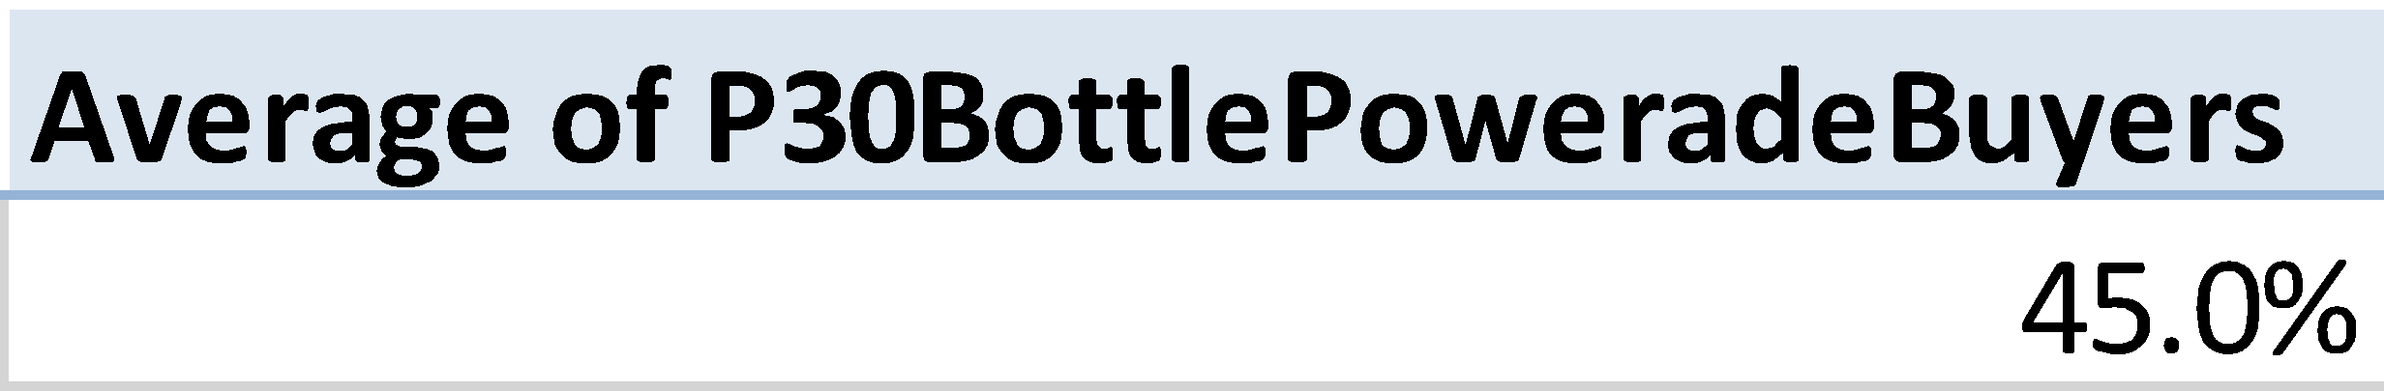

1. Create a new variable for Gatorade triers (or buyers). Copy and paste the XL code used to create this variable

**=IF(B2="","",IF(B2>=1,1,0))**

1. How many Gatorade buyers are there (you will need to create a new variable in XL to answer this question)?

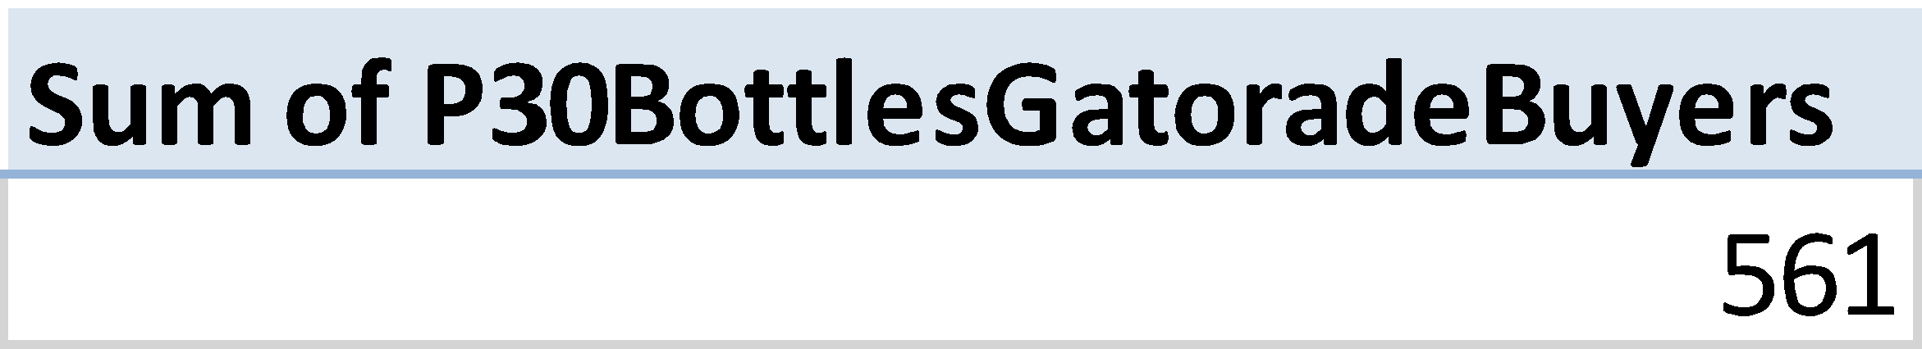

1. What percent of the sample are Gatorade buyers?

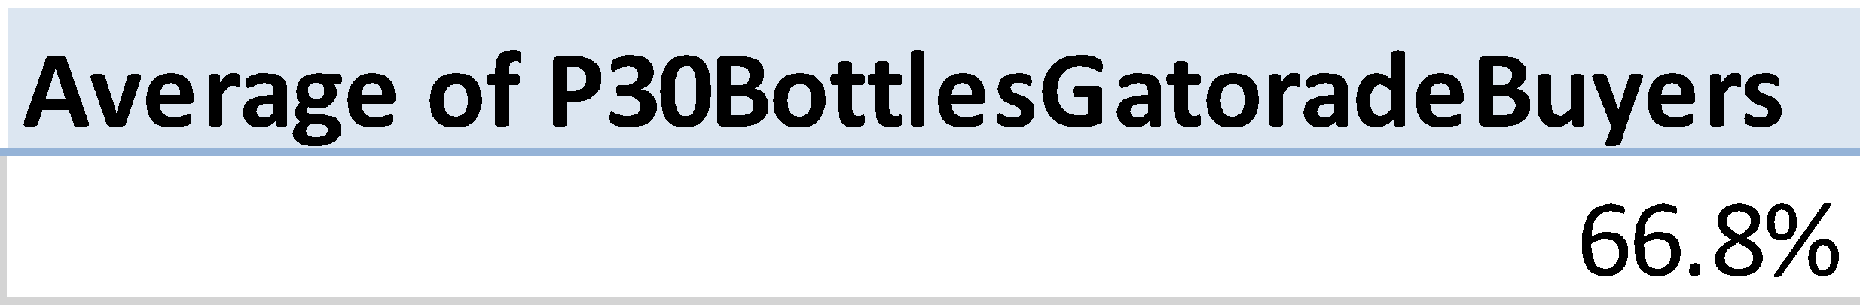

1. Create a new variable for Powerade repeaters. Copy and paste the XL code used to create this variable

**=IF(C2="","",IF(C2=0,"",IF(C2>=2,1,0)))**

1. How many Powerade repeaters are there (you will need to create a new variable in XL to answer this question)?

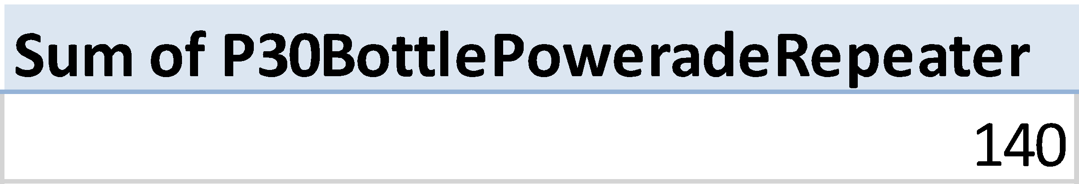

1. What is the repeat rate for Powerade

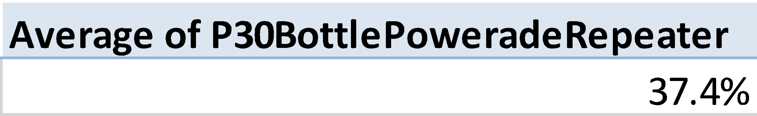

1. Create a new variable for Gatorade repeaters. Copy and paste the XL code used to create this variable

**=IF(B2="","",IF(B2=0,"",IF(B2>=2,1,0)))**

1. How many Gatorade repeaters are there (you will need to create a new variable in XL to answer this question)?

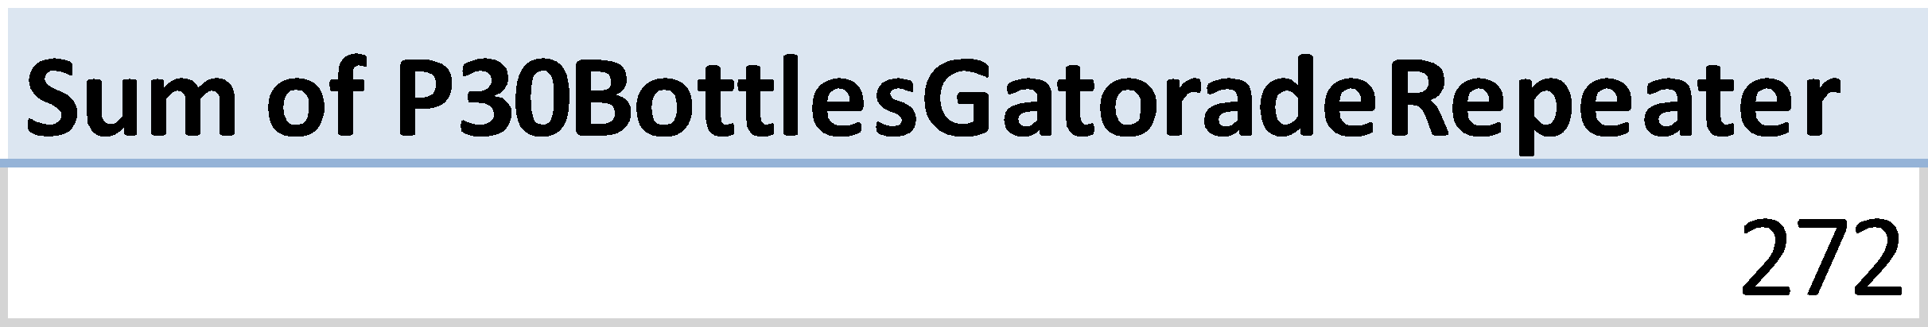

1. What is the repeat rate for Gatorade

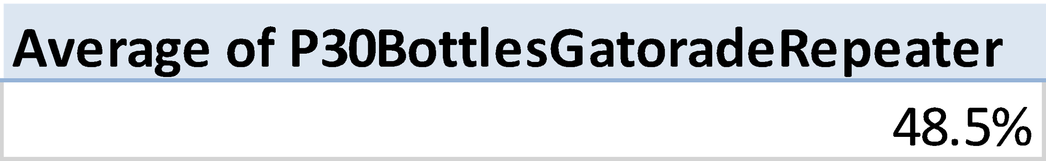

1. What is the frequency of each of the purchase options for Powerade (for P30BottlePowerade)

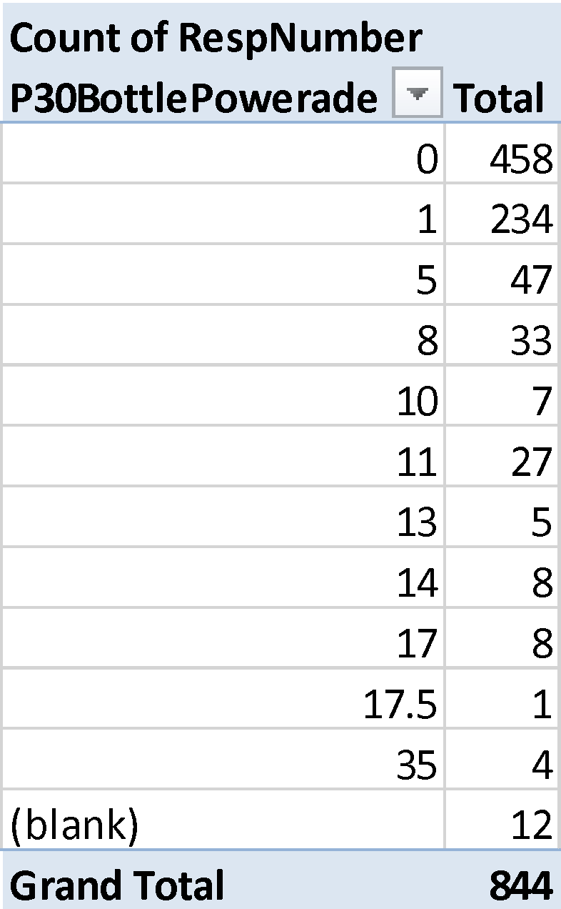

1. What is the frequency of each of the purchase options for Gatorade (for P30BottlesGatorade)

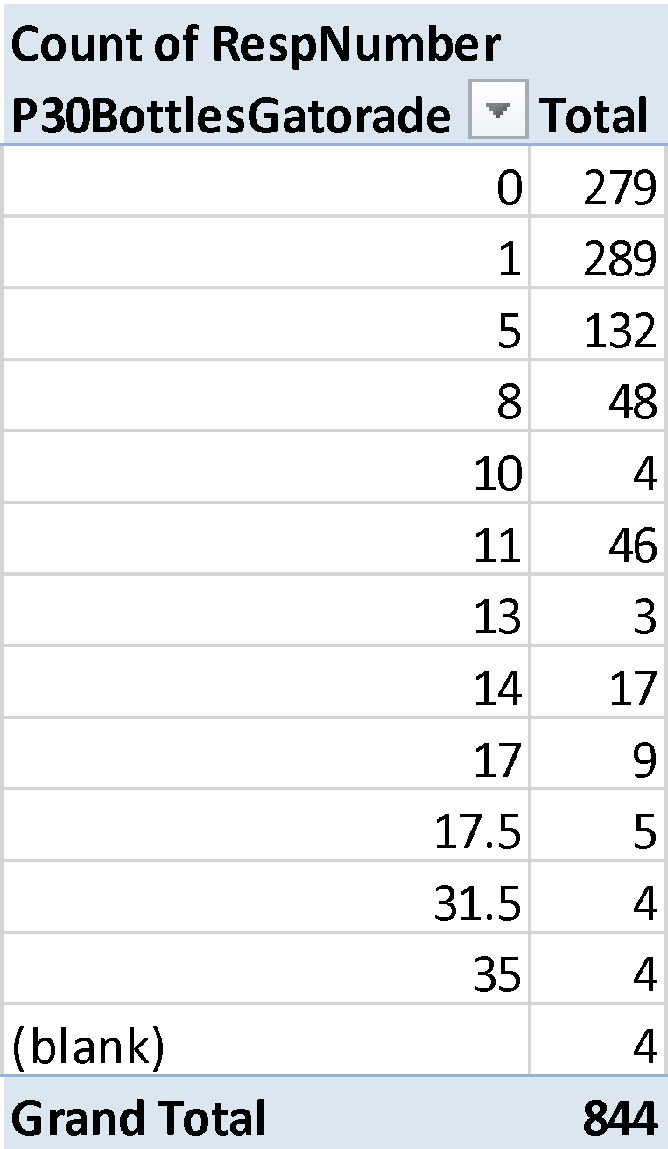

1. What is the average number of units purchased for Powerade? For Gatorade? Create a single pivot table in XL that show these values, in rank order, from low to high.

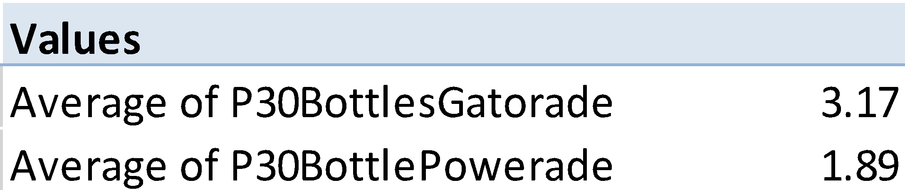

1. How many customers purchase only Powerade (i.e. loyal to Powerade)? Both Powerade and Gatorade? Gatorade only (i.e. loyal to Gatorade)? And neither brand? Please answer this question using a single pivot table.

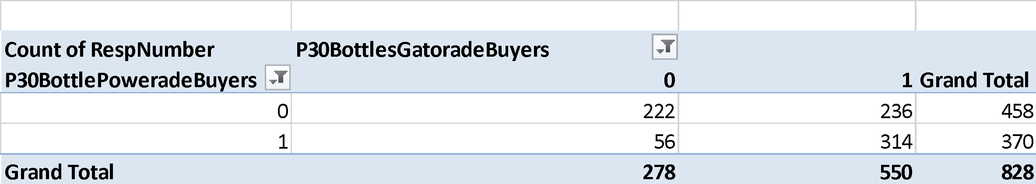

1. Based on your analysis above, what can you tell about the size of the Powerade loyal buyers? About the size of the Gatorade loyal buyers

**The size of Powerade local buyers are significantly lower than Gatorade buyers.**

**56 consumers solely bought Powerade, while 236 consumers solely bought Gatorade.**

**19. Please turn in your draft Powerade survey by the day/time announced in class**